March 9, 2026
Dear Counseling Program Review Committee,
It is my honor to recommend Quineicia Jones as she pursues opportunities in the field of clinical mental health counseling. Ms. Jones currently serves as a 4th Grade Math and Science teacher at Dunn Elementary School, where she consistently demonstrates leadership, compassion, and a deep commitment to supporting the academic and emotional development of students.
In the classroom, Ms. Jones delivers intentional, data-driven instruction designed to identify and address student misconceptions in every lesson. She consistently analyzes student work and assessment data to adjust instruction, ensuring that all students receive targeted support while being challenged to reach high academic expectations. Her approach to teaching math and science has transformed student learning experiences and students who previously lacked confidence in math are now engaged, confident, and excited to attend her class. This shift in student mindset speaks directly to her effectiveness as an instructional leader.
Beyond her classroom, Quineicia Jones plays a vital leadership role on campus through her work in Collaborative Planning and Learning (CBPL). She leads CBPL sessions with purpose and clarity, ensuring grade-level teams are aligned, prepared, and focused on delivering impactful, standards-based lessons. Her leadership has strengthened instructional practices across the team and improved student outcomes campus-wide.
Ms. Jones also demonstrates a deep commitment to the well-being of staff and students. During a year when our campus did not have a school counselor, she stepped forward to support the emotional health of our community by organizing and leading monthly mental health activities for staff. This selfless act reflects her understanding that student success is directly connected to the wellness of educators and the strength of the school community.
What truly sets Ms. Jones apart is her unwavering determination to grow her students academically, emotionally, and socially. She builds strong relationships rooted in trust,
high expectations, and encouragement, creating a classroom culture where students believe in themselves and their ability to succeed.
I strongly recommend Ms. Jones as she continues her journey into the counseling profession. Her ability to build trusting relationships, support emotional wellness, and lead with empathy will make her an outstanding counselor and advocate for those she serves.
Sincerely,
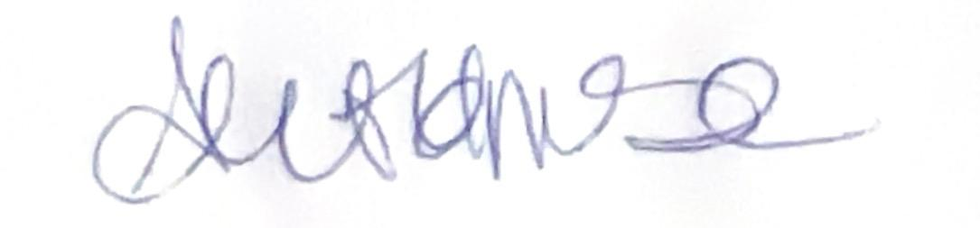
Artisha Holmes
Principal of Dunn Elementary School
Aldine Independent School District

